Style Guidelines for Final Year Project ReportsTailorMe

Final Year Project – Mid Report

Session 2021-2025

A 4th Year Student

A project submitted in partial fulfilment of the

COMSATS University Degree

of

BSc. (Hons.)BS in Computer Science / Software Engineering (CUI)



Department of Computer Science

COMSATS University Islamabad, Lahore Campus

09 December 2024

# Project Detail

|  |  |  |  |  |  |
| --- | --- | --- | --- | --- | --- |
| Type (Nature of project) | | | [✓] **Development**  [ ] **Research** & **Development** | | |
| Area of specialization | | | Digital Image Processing & Computer Vision | | |
| **Project Group Members** | | | | | |
| Sr.# | Reg. # | Student Name | | Email ID | *Signature |
| (i) | FA21-BCS-006 | Muhammad Ali | | MuhammadAli.16k@gmail.com |  |
| (ii) | FA21-BCS-066 | Muhammad Yaqoob | | yaqoobk960960@gmail.com |  |
| (iii) |  |  | |  |  |

*The candidates confirm that the work submitted is their own and appropriate credit has been given where reference has been made to the work of others

# Plagiarism Free Certificate

This is to certify that, I am ________________________ S/D/o _______________________, group leader of FYP under registration no CIIT/_________________/LHR at Computer Science Department, COMSATS University Islamabad, Lahore Campus. I declare that my FYP report is checked by my supervisor and the similarity index is ________% that is less than 20%, an acceptable limit by HEC. Report is attached herewith as Appendix A.

Date: ____________ Name of Group Leader: ________________________ Signature: _____________

Name of Supervisor: _____________________ Co-Supervisor (if any):____________________

Designation: _____________________ Designation: _____________________

Signature: _____________________ Signature: _____________________

**Abstract**

Clothing measurements, particularly for tailored garments, often require precise and efficient methods, which is usually done through manual measurements and this requires being physically present at the shopping venue and the availability of measuring tools such as a measuring tape.  
  
Hence we have proposed TailorMe, a body measurement application, that aims to address this issue by leveraging image processing techniques. The application processes user-uploaded images to measure body dimensions such as neck, waist, shoulders, chest, height, and arm length.   
  
Our goal is to create a user-friendly application that enables users to take or upload images, receive their measurements, and obtain clothing size recommendations. We also want to accommodate desi (South Asian) and western clothing preferences and provide classifications for different user categories (children and adults), ensuring inclusivity.

We hope to offer a practical solution to simplify the tailoring process and reduce the number of returns that happen during online shopping because of mismatched sizes.

Table of Contents

1 Introduction 8

2 Styles in Word 8

3 Page Layout & Size 10

4 Headings 10

4.1 Second Level Headings 11

4.1.1 Third Level Headings 11

4.2 A Word on Numbering 11

5 Figures and Charts 11

6 Program Code 12

7 Table of Contents 12

8 Final Year Project (FYP) Report Outline 13

9 References 14

**List of Tables**

Table 1 Literature review sources 1

**List of Figures**

Figure 1 Selecting the Heading 1 style from the Word style menu. 7

# Introduction

## Introduction

Clothing measurements are a crucial aspect of tailoring and garment shopping, yet many individuals struggle with obtaining precise and consistent body measurements. This is particularly challenging when tailoring traditional or custom-made clothing, where accurate measurements are essential for a proper fit. To address this issue, we propose **TailorMe**, a body measurement application that utilizes image processing techniques to provide users with accurate and efficient measurements.

**This app** aims to change how people measure their body dimensions by introducing a simple and user-friendly platform that leverages technology. Using a smartphone camera, users can take or upload photos, which are processed to extract key measurements such as neck size, waist, shoulders, chest, height, and arm length. The application also recommends clothing sizes based on these measurements, catering to both desi and western clothing preferences.

The backend of **the app**, built with Python and powered by libraries like OpenCV, handles image processing and measurement extraction. The frontend, designed in React Native, provides users with an intuitive interface to interact with the app. By integrating advanced image analysis techniques, the app ensures inclusivity by accommodating children and adults and offering gender-specific sizing recommendations. This innovative approach reduces dependency on manual measurements, saving time and effort for users while ensuring accuracy.

This introduction provides a foundation for this project, outlining its objectives and scope while highlighting its potential to simplify tailoring and garment shopping experiences for users worldwide.

## Objectives

• Provide reliable body measurements using image processing techniques.

• Offer sizing recommendations for desi and western clothing.

• Ensure inclusivity by supporting measurements for children, adult males, and adult females.

• Create a user-friendly application for taking and uploading images for measurements.

• Reduce dependency on manual measurement methods.

## Problem statement

Accurate body measurements are essential for tailored clothing and garment shopping, yet traditional manual methods are prone to errors and inconsistencies. This often results in ill-fitting garments and a time-consuming tailoring process. Additionally, there is no accessible tool for users to measure their bodies accurately using their smartphones. The absence of such a tool limits the ability to quickly obtain precise measurements for various clothing types, especially for desi attire where standard size charts may not suffice. This highlights the need for an innovative solution to simplify the measurement process and ensure accuracy in clothing fit.

## Assumptions & constraints

### Assumptions

* Users will upload clear and well-lit images for accurate measurements.
* Smartphones with cameras are widely available for app users.
* Measurement results will comply with standard size recommendations.
* Privacy and security of user images and data will be maintained.

### Constraints

* Image quality directly affects measurement accuracy.
* The app must function efficiently on resource-limited devices.
* Limited time for development and testing phases.
* Ensuring compatibility across diverse body shapes and sizes.

## Project scope

### What to Consider

• Development of a backend for image processing and measurement extraction using Python.

• React Native frontend for a seamless user interface.

• Support for different clothing styles (desi and western).

• Categorization of users into children, adult males, and adult females.

• Integration of security measures for image data storage and processing.

### What to not Consider

• Advanced AI features like predictive sizing beyond measurements.

• Integration with third-party clothing brands for virtual try-ons.

• Detailed customization options for niche clothing types.

• Extensions beyond core functionality like body posture analysis.

# Requirement Analysis

We identify the requirements here and give a brief description of them in a conclusive way.

## Literature review / Existing system study

Various research and development efforts have been made in body measurement extraction. Previous work includes techniques in computer vision, such as contour detection and key-point estimation using libraries like **OpenPose** 1.

During our research we came across apps like **MirrorSize** 2, which uses AI for body measurements. **3DLOOK** 3**,** an app that captures over 80 points of measurement using just two photos taken by the user. **Bodymapp** 4**,** a3D body scanning app that allows users to measure and track their body composition and circumference measurements using an iPhone X or above.

We also came across the following Studies and research papers:

1. A Review of Body Measurement Using 3D Scanning 5: <https://www.researchgate.net/publication/351207865_A_Review_of_Body_Measurement_Using_3D_Scanning>
2. This study focused on estimating upper body dimensions using a single RGB camera, such as those found on smartphones. The process involved several steps, including image calibration and feature extraction, to accurately derive body measurements 6: <https://www.semanticscholar.org/paper/Measuring-the-Human-Body-from-a-Single-Camera%2C-with-Montazerian-LEYMARIE/ae8c70ec2e5fe71f7692f51a9f7527f173d46f41?utm_source=direct_link>
3. Designing a Contactless, AI System to Measure the Human Body using a Single Camera for the Clothing and Fashion Industry – University of London 7:  
   <https://www.researchgate.net/publication/373343443_Designing_a_Contactless_AI_System_to_Measure_the_Human_Body_using_a_Single_Camera_for_the_Clothing_and_Fashion_Industry>
4. Automatic Extraction of 3D Body Measurements from 2D Images: This paper proposes an automated system that extracts body measurements from 2D images, facilitating better garment fitting for small businesses. The system was tested on images of young females, comparing the results with manual measurements to validate its accuracy 8~ <https://www.semanticscholar.org/paper/Automatic-Extraction-of-3-d-Body-Measurements-from-Sehgal-Gupta/d49108ddfdeb2ddf973589bb078000274ee7fb01>

## Stakeholders list (Actors)

### Primary Stakeholders:

* End Users: Individuals seeking tailored clothing or size recommendations.
* Tailors and Designers: Utilize accurate measurements for better results.

### Secondary Stakeholders:

* Developers: Building and maintaining the application.
* Retailers: Potential future integration for online shopping.

## Requirements elicitation

## Functional requirements

## Non-functional requirements

## Requirements traceability matric

## Use case descriptions

## Use case design

## Software development life cycle model

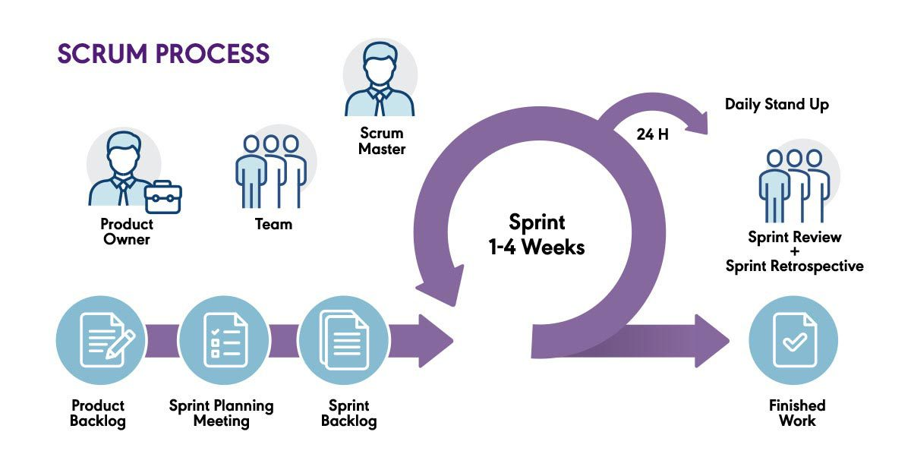

Figure 1 Software Development Life Cycle

**Selected Model: Scrum**

* **Reason**: Scrum provides a structured framework that aligns with the iterative nature of **TailorMe** development, allowing efficient progress through defined roles, events, and deliverables.

**Justification:**

* **Time-Boxed Iterations (Sprints)**: Enables the team to focus on small, manageable goals (e.g., building the measurement algorithm in one sprint and refining the React Native interface in another).
* **Roles**:
  + **Product Owner**: Oversees project vision and backlog (e.g., ensuring alignment with user needs for measurement features).
  + **Scrum Master**: Facilitates sprint planning and resolves roadblocks.
  + **Development Team**: Implements the features, such as backend algorithms and frontend interfaces.
* **Events**:
  + **Sprint Planning**: Define sprint goals, such as integrating the image processing module.
  + **Daily Standups**: Synchronize progress and address challenges.
  + **Sprint Reviews**: Demonstrate completed functionalities (e.g., showing working measurement extraction).
  + **Retrospectives**: Reflect on sprints to improve future development.
* **Artifacts**:
  + **Product Backlog**: List of all project requirements, including measurement accuracy and frontend usability.
  + **Sprint Backlog**: Tasks for each sprint, such as implementing specific body measurements.
  + **Increment**: Deliverable at the end of each sprint, like a functioning measurement feature.

**Benefits of Scrum for TailorMe:**

* Flexibility to refine features like measurement accuracy based on user feedback.
* Continuous delivery ensures regular progress updates for stakeholders.
* Clear roles and defined sprints enhance collaboration and productivity.

# System Design

## Work breakdown structure (WBS)

The Work Breakdown Structure (WBS) divides the project into manageable tasks and sub-tasks, ensuring a clear understanding of each phase of development. It provides a hierarchical view of the project components, helping to organize, schedule, and track progress efficiently.

## Activity diagram

AD01 – Signup

AD02 – Login

AD03 – Forgot Password

AD04 – Reset Password

AD05 – Logout

AD06 – Update Profile

AD07 – Taking a Photo for measurement

AD08 – Uploading an Existing Photo

AD09 – Getting Clothing Recommendation

AD10 – History of Past Measurements & Clothing Recommendations

AD11 – Database management

## Sequence diagram

SD01 – Sign up

SD02 – Profile Creation

SD03 – Login

SD04 – Forgot Password

SD05 – Taking a Photo for measurement

SD06 – Uploading existing photo

SD07 – Retrieving Measurements

SD08 – Getting Clothing Recommendation

SD09 – User Feedback

## Software architecture

Client-Side UI/UX will be made through **React-Native**. Which has been chosen for its cross-platform compatibility (IOS and Android).

Python Model will be executed in the Backend layer to manage core functionalities, such as measuring user inputs and storing measurement data. The backend can be developed using **FastAPI** or other frameworks.

A SQL based database management system, like **PostgreSQL**,etc, can be used for building a Database. It will store critical user data, such as body measurements, user profiles, etc.

The application can be deployed in a cloud environment, such as **AWS** or **Google Cloud**, etc. It can also be deployed on a local machine for demonstration. The backend can be hosted using **Gunicorn** to manage the FastAPI application. **Docker** can be used for containerization.

## Class diagram

## Database diagram

## Network diagram (Gantt chart)

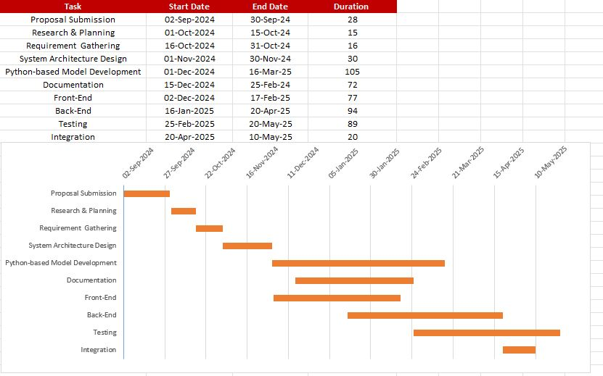

## Collaboration diagram

Login

Reset Password

Upload Picture for Measurement

Take Picture for Measurement

Get History of Past Measurements and Recommendations

# System Testing

## Test cases

## Unit

## Integration

## Acceptance testing

# Conclusion

## Problems faced and lessons learned

## Project summary

## Future work

# References

[1]***Z. Cao, G. Hidalgo, T. Simon, S.-E. Wei, and Y. Sheikh,***"OpenPose: Realtime Multi-Person 2D Pose Estimation Using Part Affinity Fields," *IEEE Transactions on Pattern Analysis and Machine Intelligence, vol. 43, no. 2, pp. 172-186, 2018. [Online]. Available:*[*https://arxiv.org/pdf/1812.08008.pdf*](https://arxiv.org/pdf/1812.08008.pdf)*.*

[2]***Mirrorsize****. "Ultimate Body-Measuring App for Perfectly Fitting Clothes." [Online]. Available:*[*https://www.mirrorsize.com/blogs/ultimate-body-measuring-app-for-perfectly-fitting-clothes*](https://www.mirrorsize.com/blogs/ultimate-body-measuring-app-for-perfectly-fitting-clothes)*.*

[3]***3DLOOK****.* "3DLOOK" *[Online]. Available:*[*https://3dlook.ai/content-hub/3dlook-is-a-member-of-the-mobile-body-scanning-standards-developed-by-ieee/*](https://3dlook.ai/content-hub/3dlook-is-a-member-of-the-mobile-body-scanning-standards-developed-by-ieee/)*.*

[4]***Bodymapp.*** *"3D Body Scanning App | Health and Fitness Tracker." [Online]. Available:*[*https://bodymapp.co*](https://bodymapp.co/)*.*

[5] ***Kristijan Bartol, David Bojanić, Tomislav Petković, Tomislav Pribanic,****"A Review of Body Measurement Using 3D Scanning," ResearchGate, 2022. [Online].* Available: <https://www.researchgate.net/publication/351207865_A_Review_of_Body_Measurement_Using_3D_Scanning>.

[6] ***M. Montazerian and L. LEYMARIE,****"Measuring the Human Body from a Single Camera," Semantic Scholar, 2022. [Online]. Available:*[*https://www.semanticscholar.org/paper/Measuring-the-Human-Body-from-a-Single-Camera%2C-with-Montazerian-LEYMARIE/ae8c70ec2e5fe71f7692f51a9f7527f173d46f41?utm_source=direct_link*](https://www.semanticscholar.org/paper/Measuring-the-Human-Body-from-a-Single-Camera%2C-with-Montazerian-LEYMARIE/ae8c70ec2e5fe71f7692f51a9f7527f173d46f41?utm_source=direct_link)*.*

[7] ***University of London,****"Designing a Contactless AI System to Measure the Human Body using a Single Camera for the Clothing and Fashion Industry," ResearchGate, 2023. [Online]. Available:*[*https://www.researchgate.net/publication/373343443_Designing_a_Contactless_AI_System_to_Measure_the_Human_Body_using_a_Single_Camera_for_the_Clothing_and_Fashion_Industry*](https://www.researchgate.net/publication/373343443_Designing_a_Contactless_AI_System_to_Measure_the_Human_Body_using_a_Single_Camera_for_the_Clothing_and_Fashion_Industry)

[8] ***A. Sehgal and A. Gupta,****"Automatic Extraction of 3D Body Measurements from 2D Images," Semantic Scholar, 2022.*

# Table of Contents

A table of contents (TOC) page has also been included in this report template and can be created using the TOC generator in Word. Ordinarily this is accessed via *Index and Tables* option in the in the *Insert* menu. However, to avoid the need to set certain TOC features, the best way to insert a new table of contents is to use the TOC macro defined in this document. This macro can be run by clicking on the *TOC* button on the report style toolbar to position a new table of contents at the current cursor position – so care needs to be take to properly position the cursor after he “table of contents” heading on page 3 of your report. Notice that you can update your existing table of contents by simply right clicking it and selecting the *update field* option.

A word of warning on this feature – the table of contents is automatically generated by compiling a table of all of the level 1, 2 and 3 headings in your document. This means that every line with one of these styles will appear in the table. If you use these styles for non-headings (of course you should not do this) then these non-headings will also appear in the table.

# Final Year Project (FYP) Report Outline

**Chapter 1: Introduction**

* Introduction
* Objectives
* Problem statement
* Assumptions & constraints
* Project scope (what and what not to consider)

**Chapter 2: Requirements Analysis**

* Literature review / Existing system study
* Stakeholders list (Actors)
* Requirements elicitation
  + Functional requirements
  + Non-functional requirements
  + Requirements traceability matric
* Use case descriptions
* Use case design
* Software development life cycle model (justification on why this particular model is considered)

**Chapter 3: System Design**

* Work breakdown structure (WBS)
* Activity diagram
* Sequence diagram
* Software architecture
* Class diagram
* Database diagram
* Network diagram (Gantt chart)
* Collaboration diagram

**Chapter 4: System Testing**

* Test cases
* Unit / integration / acceptance testing

**Chapter 5: Conclusion**

* Problems faced and lessons learned
* Project summary
* Future work

# References

References to any book, journal paper or website should properly be acknowledged, For example.

1. Lyda M.S. Lau, Jayne Curson, Richard Drew, Peter Dew and Christine Leigh, (1999), Use Of VSP Resource Rooms to Support Group Work in a Learning Environment, ACM 99, pp-2. (Journal paper example)
2. Hideyuki Nakanishi, Chikara Yoshida, Toshikazu Nishmora and Turu Ishada, (1996), FreeWalk: Supporting Casual Meetings in a Network, pp 308-314 (paper on web)
   1. <http://www.acm.org/pubs/articles/proceedings/cscw/240080/p308-nakanishi.pdf>
3. Ali Behforooz & Frederick J.Hudson, (1996), Software Engineering Fundamentals, Oxford University Press. Chapter 8, pp255-235. (book reference example)
4. <http://www.bt.com/bttj/archive.htm> (web site)

APPENDICES

1. ANY OTHER SUPPORTING SCHEDULES or DOCUMENTS

Appendix A

*Include here the 1st page of Turnitin Report*

Every supervisor has his/her own Turnitin account. If not then the supervisors are requested to get the account from Library as soon as possible.